Software Requirements Specification
for
Airo-Aether Digital notice board system
Version <1.0>

Prepared by
Group number: 18
Anuj Jandhyala | SE23UMCS017 | se23umcs017@mahindrauniversity.edu.in
Abhinav Simha | SE23UARI001 | se23uari001@mahindrauniversity.edu.in
Ankit Parupalli  Aryan Gumidelli  Venkat Akshay | SE23UMCS003  SE23UMCS006  SE23UARI132 | se23umcs003@mahindrauniversity.edu.in  se23umcs006@mahindrauniversity.edu.in  se23uari132@mahindrauniversity.edu.in
Harshith Kottamasu | SE23UMCS029 | e23umcs029@mahindrauniversity.edu.in
Gynanesh | SE23UARI100 | se23uari100@mahindrauniversity.edu.in

Instructor: | Avinash Arun Chauhan
Course: | Software Engineering
Lab Section: | AI, CS4
Teaching Assistant: | Surya Phani Teja
Date: | 16/03/2026
Contents
Contents i
Revisions ii
1 Introduction 1
1.1 Document Purpose 1
1.2 Product Scope 1
1.3 Intended Audience and Document Overview 1
1.4 Definitions, Acronyms and Abbreviations 1
1.5 Document Conventions 2
1.6 References and Acknowledgments 2
2 Overall Description 3
2.1 Product Overview 3
2.2 Product Functionality 3
2.3 Design and Implementation Constraints 3
2.4 Assumptions and Dependencies 4
3 Specific Requirements 4
3.1 External Interface Requirements 4
3.2 Functional Requirements 5
3.3 Use Case Model 5
4 Other Non-functional Requirements 9
4.1 Performance Requirements 9
4.2 Safety and Security Requirements 9
4.3 Software Quality Attributes 10
5 Other Requirements 10
Appendix A – Data Dictionary 11
Appendix B - Group Log 12

Revisions
Version | Primary Author(s) | Description of Version | Date Completed
Draft 1.0 | Ankit Parupalli, Anuj Jandhyala | Information about the revision. This table does not need to be filled in whenever a document is touched, only when the version is being upgraded. | 16/03/2026

Introduction
To build and design a digital notice board system that allows authorized personnel to post updates and announcements digitally.

Moreover, this system is event-adaptive that is - it supports all the events that take place in Mahindra University including the two major events – Airo (sport fest) and Aether (cultural fest) by displaying live sports events updates during Airo and also provide dress themes and screening announcements during Aether.

Document Purpose
This document provides the requirements specification for the AIRO-Aether Digital Notice Board System. It describes the functional and non-functional requirements of the system and defines the expected behavior of the software.

The purpose of this document is to provide a clear understanding of the system requirements to developers, project stakeholders, and instructors. Moreover, it will serve as a reference during system development and testing.

Product Scope
The AIRO-Aether Digital Notice Board System is a software platform designed to digitally manage and display notices, announcements, and information on electronic display boards.

The system allows administrators to upload, edit, and schedule notices, which will be displayed on digital screens placed in institutions such as colleges, offices, or public spaces.

Intended Audience and Document Overview
The system allows administrators to upload, edit, and schedule notices, which will be displayed on digital screens placed in institutions such as colleges, offices, or public spaces.

The document overview is as follows:
- Section 1 – Introduction and overview
- Section 2 – Overall description of the system
- Section 3 – Detailed system requirements
- Section 4 – Non-functional requirements
- Section 5 – Additional requirements and appendices

Definitions, Acronyms and Abbreviations
Context Switch: Context switching refers to the system’s ability to dynamically change the displayed content and functionality based on the currently active event, such as AIRO or AETHER.

TERM | MEANING
AIRO | ANNUAL SPORT FEST
AETHER | ANNUAL CULTURAL FEST

Document Conventions
This document follows the IEEE Software Requirement Specification (SRS) standard structure. Requirements are organized into sections and numbered for clarity and traceability. Functional requirements are written using the keyword “shall” to represent mandatory system behavior. Tables and diagrams are used to represent system architecture and relationships. Technical terms and acronyms are defined in the Definitions section. All headings and subheadings follow a hierarchical numbering format to improve readability.

References and Acknowledgments
- IEEE Software Requirement Specification Standard
- PostgreSQL Documentation
- Node.js Documentation

Overall Description

Product Overview
The system acts as a centralized digital notice board that integrates a frontend interface with a backend server and database. The backend manages data storage and API requests while the frontend displays real-time updates.

The architecture for the system is as follows:

Frontend (React)
↓
Backend (Node.js / Express)
↓
PostgreSQL Database
↓
Firebase (Real-time updates)

Product Functionality
The major functions of the system are to:

- Display notices
- Display live sports scores
- Show dress themes
- Allow admin to add notices
- Display real-time updates

Design and Implementation Constraints
The following constraints affect the design and implementation of the AIRO–AETHER Digital Notice Board System:
- The backend must be implemented using Node.js with the Express framework.
- The system database must use PostgreSQL for persistent data storage.
- Firebase Realtime Database will be used for live score updates and real-time notifications.
- The frontend interface will be developed using React.
- The system must follow the COMET (Concurrent Object Modelling and Architectural Design Method) for software design.
- System models and diagrams must be created using UML (Unified Modelling Language).
- The system must run on standard web browsers without requiring specialized hardware.
- Development will use Git and GitHub for version control.
- The system must support real-time updates during AIRO sports events.
References
- Gomaa, H. Designing Concurrent, Distributed, and Real-Time Applications with UML.
- IEEE UML Modelling Standard

Assumptions and Dependencies
The following assumptions and dependencies are considered during system development:

- It is assumed that administrators will regularly update notices and match scores.
- The system depends on the PostgreSQL database server being available.
- The system depends on Firebase services for real-time updates.
- Users will access the notice board through modern web browsers/web application (in future).
- The display screen or projector used for the notice board will either be using the web application or be connected to a monitor.

Specific Requirements

External Interface Requirements

User Interfaces
The system provides a digital notice board interface displayed on a screen or projector. Users interact with the system through a graphical web interface.
The interface contains the following sections:
- Notice display panel
- Live sports score panel
- Dress theme display
- Event announcements
- Admin dashboard for updating information
The interface will support touch input or mouse interaction for administrative operations. General users will only be able to view information.

Hardware Interfaces
The system interacts with the following hardware components:
- Computer system hosting the application
- Display screen or projector used as the digital notice board
- Internet network interface for communication with Firebase and backend services
- Optional touchscreen display for administrator interaction

Software Interfaces
The system interacts with the following software components:
- PostgreSQL database – stores notices, match information, and themes
- Firebase Realtime Database – provides real-time updates for sports scores
- Web browsers – users access the frontend through standard browsers
- Node.js backend server – handles API requests and database operation

Functional Requirements

F1: Display Notices

The system shall display event notices to users on the digital notice board.

F2: Add Notices

The system shall allow administrators to add new notices.

F3: Update Match Scores

The system shall allow administrators to update live sports match scores.

F4: Display Dress Themes

The system shall display the daily dress theme during AETHER events.

F5: Context Switching

The system shall automatically switch displayed content based on the current event context (AIRO or AETHER).

F6: Retrieve Data

The system shall retrieve data from the PostgreSQL database.

F7: Real-Time Updates

The system shall update sports scores in real time using Firebase.

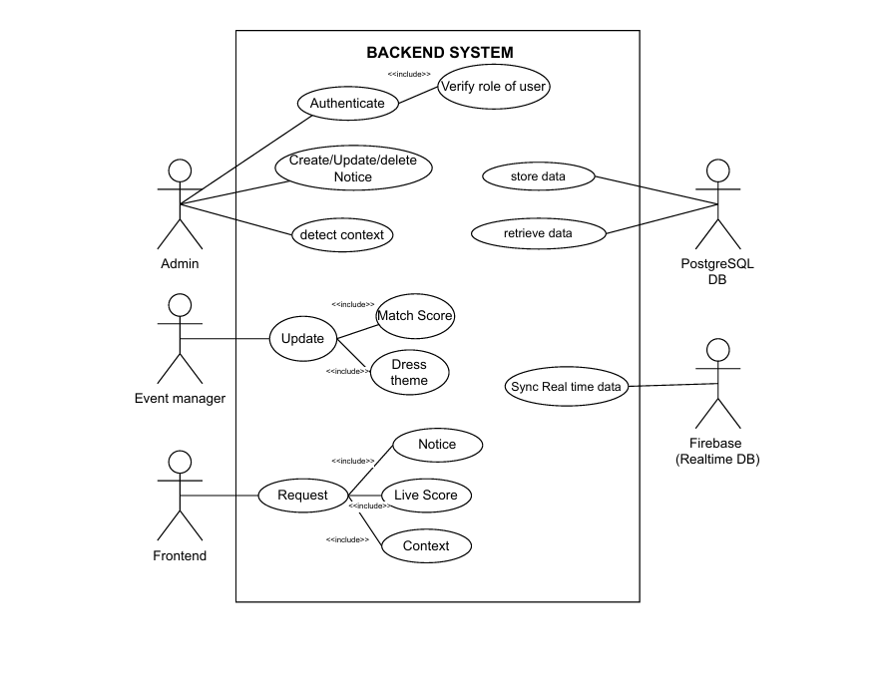
Use Case Model

U1 - Backend system
Authors – Anuj Jandhyala, Harshith Kottamasu
Purpose - The backend system of the AIRO–AETHER Digital Notice Board System manages data processing, authentication, and communication with external services such as the PostgreSQL database and Firebase realtime database. The backend acts as an intermediary between the frontend interface and the data storage systems.
Requirements Traceability – F2 (Add Notice), F8 (Retrieve Data), F9 (Real-Time Updates)
Priority – F8.F9 – High priority.
Preconditions:
- The administrator must be authenticated.
- The backend server and database must be operational.
Post conditions:
- A new notice is stored in the PostgreSQL database.
- The notice becomes visible on the notice board interface.
Actors:
Primary: Admin, Event manager, Frontend
Secondary: PostgreSQL DB, Firebase
Flow of Events
  - Basic Flow:
• Admin logs into the system.
• Admin selects the "Add Notice" option.
• Admin enters notice details (title, description, event type).
• System validates the input.
• System stores the notice in the database.
• System updates the notice board display.
  - Alternative Flow:
• Admin submits incomplete information.
• System displays validation error.
  - Exceptions –
• Database connection failure.
• Server error during notice creation.

Includes – Authenticate, Request, Update

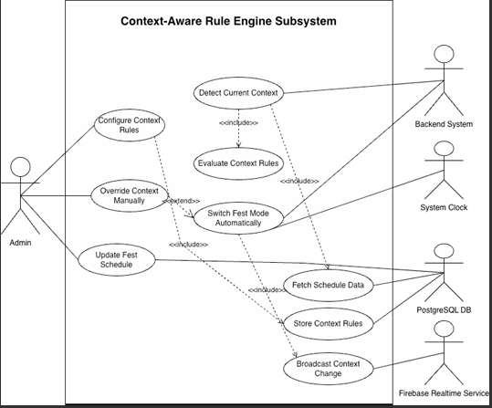
U2 – Context-Aware Rule Engine Subsystem

Authors – Aryan Gumidelli, Akshay
Purpose - The Context-Aware Rule Engine subsystem determines the active event context (AIRO or AETHER) based on predefined rules, schedules, or manual overrides. It evaluates context rules, retrieves schedule information from the database, and automatically updates the system mode when necessary. When a context change occurs, the system broadcasts the update to other components such as the backend system and frontend interface.
Requirements Traceability – F7, F8, F9.
Priority – F7 – High priority.
Preconditions:
- The system must be running.
- Context rules must be configured by the administrator.
- Backend services and PostgreSQL database must be operational.
Post conditions:
- The system determines the correct event context.
- If a context change occurs, the system updates the active event mode.
- The updated context is broadcast to all connected services
Actors:
Primary: Admin, Backend system.
Secondary: System clock. PostgreSQL DB, Firebase.
Flow of Events
Basic Flow:
• Admin configures context rules or event schedules.
• The rule engine retrieves schedule data from the PostgreSQL database.
• The system clock provides the current time.
• The rule engine detects the current context.
• The system evaluates the configured context rules.
• The system determines whether the event mode should change.
• If a change is required, the system switches the fest mode automatically.
• The system broadcasts the context change using Firebase.
• Backend and frontend systems update the displayed information
Alternative Flow:
  - Admin manually overrides the context mode.
  - The system switches to the selected context immediately.
  - The updated context is broadcast to all services.
Exceptions:
• Database connection failure when retrieving schedule data.
• Firebase service unavailable for broadcasting updates.
• Invalid context rules configuration.

Extends – Override context manually
Note - Future implementations may support automatic context detection based on external event feeds.

Other Non-functional Requirements

Performance Requirements
There are numerous Non-functional requirements that need to be met, of those, the following are of highest priority:
P1: The system shall update match scores within 2 seconds of a change.
P2: The system shall support at least 100 simultaneous viewers.
P3: The notice board interface shall load within 3 seconds.

Safety and Security Requirements
• Only authenticated administrators shall be allowed to modify notices.
• All administrator actions must require login authentication.
• Data communication between frontend and backend shall use secure HTTP (HTTPS).
• Firebase connections shall be secured using API authentication keys.

Software Quality Attributes
Reliability:
The system shall maintain continuous operation during events and automatically recover from minor failures.

Maintainability:
The system architecture will separate:
  - Frontend
  - Backend
  - Database

Usability:
The interface shall be simple and readable from a distance for display on large screens.

Other Requirements
<This section is Optional. Define any other requirements not covered elsewhere in the SRS. This might include database requirements, internationalization requirements, legal requirements, reuse objectives for the project, and so on. Add any new sections that are pertinent to the project.>

Appendix A – Data Dictionary

<Data dictionary is used to track all the different variables, states and functional requirements that you described in your document. Make sure to include the complete list of all constants, state variables (and their possible states), inputs and outputs in a table. In the table, include the description of these items as well as all related operations and requirements.>

Appendix B - Group Log
<Please include here all the minutes from your group meetings, your group activities, and any other relevant information that will assist in determining the effort put forth to produce this document>

